In order to extract data from the source system, we don ‘t blindly connect and extract the data. We need to understand the nature of the source, type of files we are dealing with, limitations if any, authentications, owner and business process the data is supporting etc.
Below picture gives a brief about the type of scenarios or the questions to be considered before starting the project. Usually, these questions are answered by the source system experts.
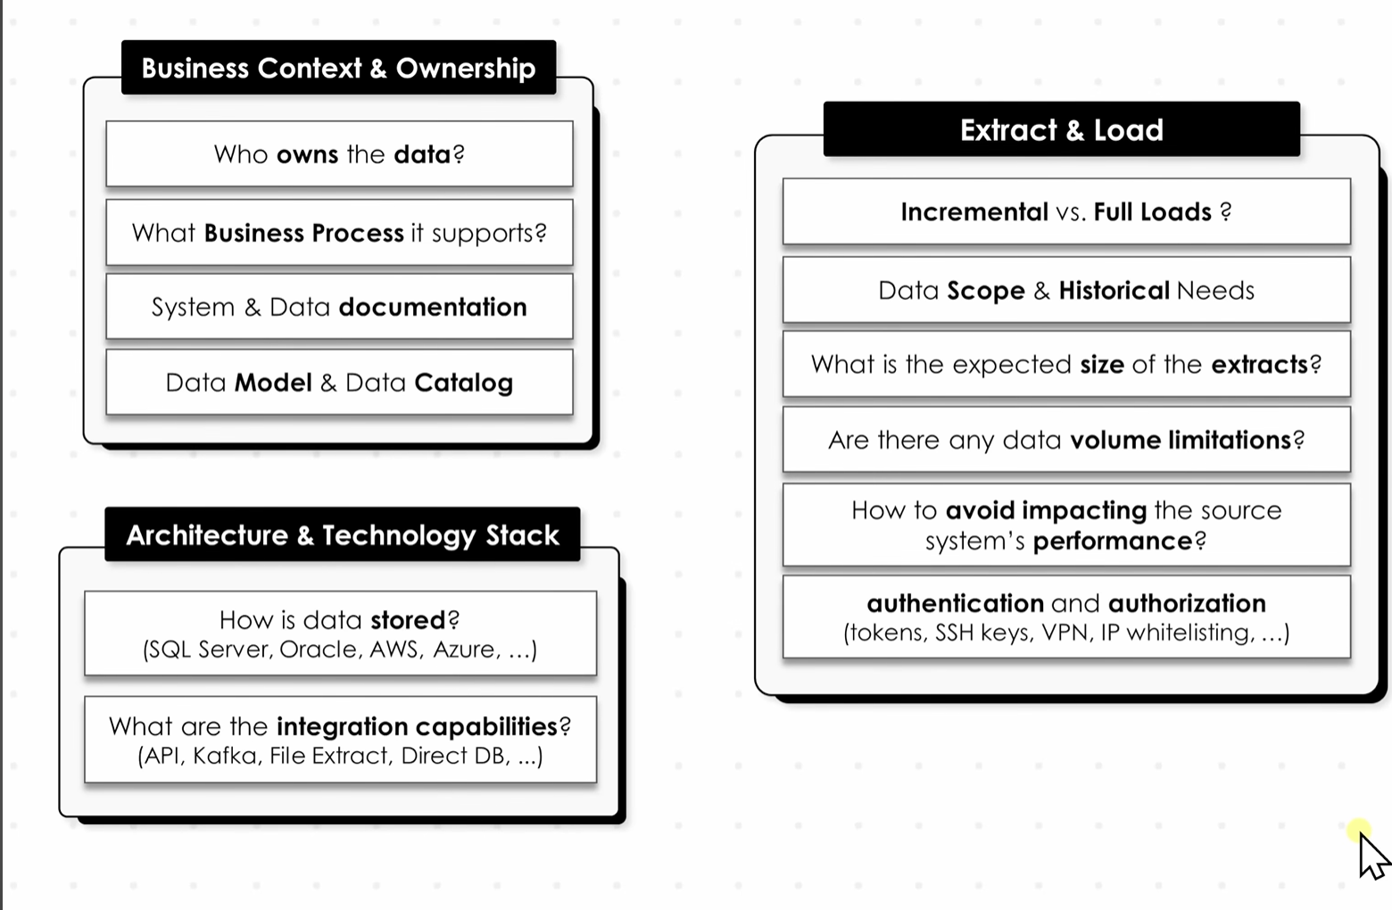

We could also do data profiling where we go analyse the source data to identify the column names and data types.

